For our exercise, we want to record audio in WAV format with sampling frequency 16000 Hz, sample size 16 bit and signed-integer encoding. If everything else fails, use the wav files which are in the drive directory recorded. But use this only as the last resort, try to record your own files!

## Linux

On Linux, you can use the rec command as

rec -b 16 -r 16000 -e signed -c 1 filename.wav

This will start the recording, which you can then end with Ctrl-C. Leave a second of silence before ending the recording, the reaction is sometimes a bit delayed and may end up cutting about half a second of the end of the recording. After recording, you can play the file with

play filename.wav

## Others

You can use online services to first record and then convert your recording to the desired format.

### Recording

<https://voice-recorder-online.com/>

You will need to allow your browser to use microphone for this one.

First, click on microphone button to start recording.

Second, click on stop button to stop recording.

Third, click on ‘Save to computer’ to download the recording.

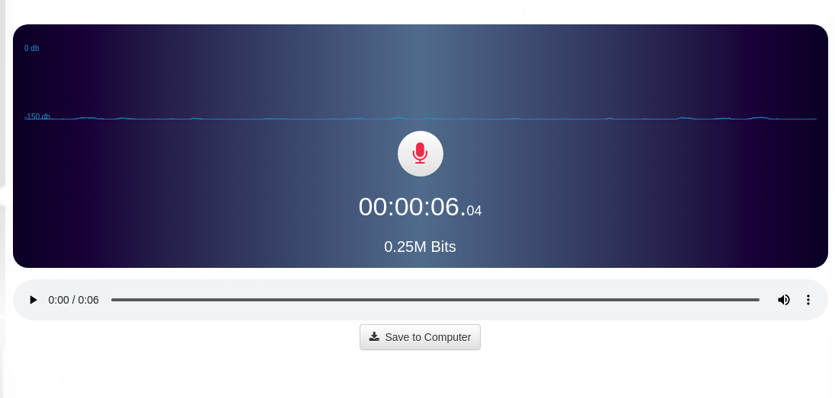

### Converting the format

<https://audio.online-convert.com/convert-to-wav>

Set the parameters as on the screenshot below (bit resolution 16 Bit, sampling rate 16000 Hz, audio channels mono). Then click ‘Choose files’, upload your files. Click ‘Start conversion’. Then download the converted files.

